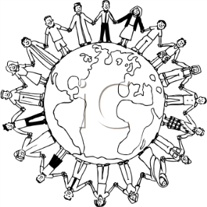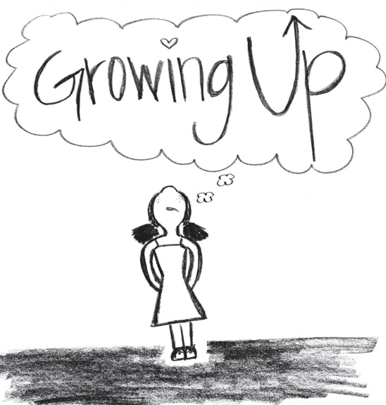**TOPIC: Growing up**

* **What kind of learner am I?**
* **Young people in literature and films**
* **Young people in different countries**

**Dealing with short stories:**

* **Comprehension**
* **Formal aspects: traditional versus modern**
* **Features of character**
* **Main stylistic devices**

**Text production:**

* **Summary Writing**
* **Form Analysis**
* **Characterization**
* **Comment**
* 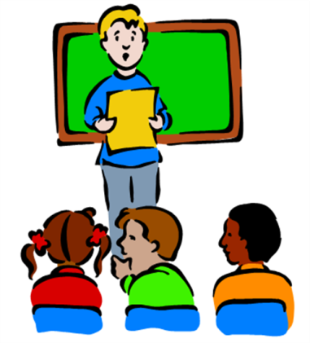**Creative Writing**

**Presentation skills**